CEE 609 Environmental Data Science

**Finding safety margin of co-registering the optical and thermal camera field of view**

Provided by:

**Fatemeh Rezaei**

**Fall 2024**

For collecting our dataset and to capture the unique spectral signature of water and allow for day/night water detection, the Flood Viz node is equipped with two cameras: a Dorhea multispectral camera (capturing red, green, blue, and near-infrared radiation) and a FLIR Lepton long-wave infrared, or thermal, camera. A typical image type is a three-channel image where each channel has scalar values in [0,255]; often, people refer to such an image as an RGB image. This terminology implies that the three channels should be interpreted using RGB color space. We have two extra bands containing Near-Infrared (NIR) and Long-Wave Infrared (LWIR). A Near-Infrared (NIR) image band is a spectral region of the electromagnetic spectrum just outside the range of human vision. NIR bands are used in image analysis and change detection, especially for vegetation and wetlands. Long-Wave Infrared, or LWIR, is a subset of the infrared band of the electromagnetic spectrum, covering wavelengths ranging from 8[µm](https://www.infinitioptics.com/glossary/micron-um) to 14µm (8,000 to 14,000nm). This is the radiant heat that uncooled thermal imaging cameras see and detect distinct temperature differences. We went into the field to gain data to start calibration, took pictures with both cameras from water bodies, and stored our data as jpg images. Later, we can store our data in NumPy arrays, a grid of values representing each pixel of images that are all the same type. In our case, the goal is to find points with the same pixel data in the two thermal and multispectral images and try to align them to get the same location and spacing for the points. That way, we could merge the two images and read all necessary data simultaneously from a combined 5-band image. For this matter, we developed a Python script using the SimpleITK toolkit. Finally, our dataset is a pair of thermal and multispectral images and a 5-band image for each scene. We also have an Excel file containing each pixel temperature for each thermal picture. After processing, these are transformed into matrices for further analysis. This data has been used to create a histogram for temperature distribution. This histogram visualizes the distribution of average temperature values calculated from 10 submatrices within each thermal image matrix.

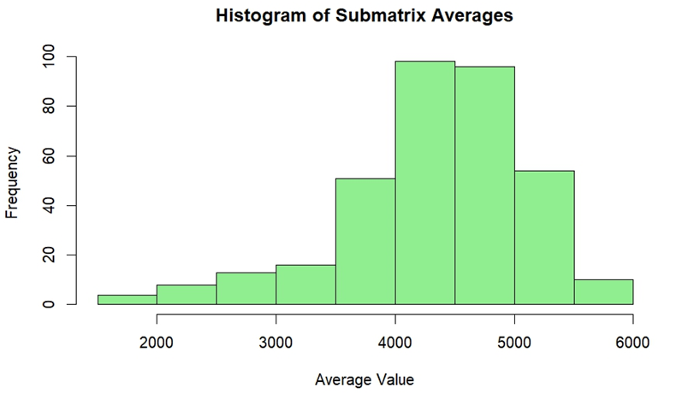

Figure - Frequency of temperature in thermal images

The boxplot illustrates the range of temperature values across all thermal images. Each box represents a specific image's statistical features of temperature values, showing the median, quartiles, and potential outliers. Sorting the boxplots by average temperature allows for identifying which images have higher or lower temperature values, providing insights into thermal conditions across different images and the amount of water and flood in each scene.

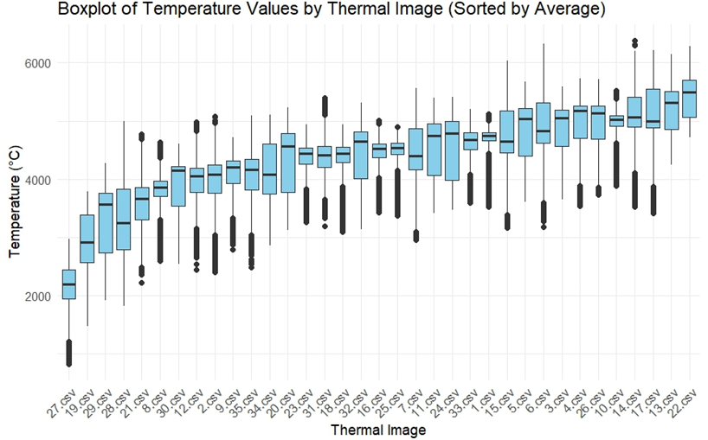

Figure - Boxplot of thermal image’s temperature values

The correlation matrix represents the relationships between the different spectral bands in the co-registered 5-band images (Red, Green, Blue, NIR, and LWIR). High correlation values between bands suggest that they are capturing similar information, while lower values may indicate distinct features. This analysis gives us a better visualization of each band's characteristics, the necessity of having them in our analysis, and an understanding of the interplay between optical and thermal data in urban environments.

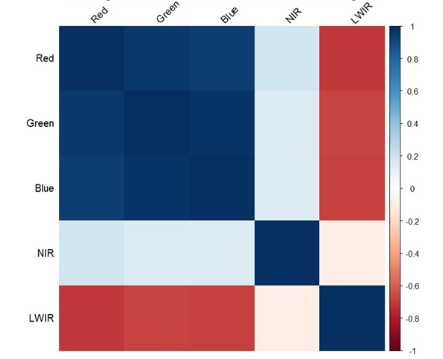

Figure -Average Correlation Matrix of Bands Across Images